Threads
A thread is the smallest unit of execution in a program. It allows multiple tasks to run concurrently in a program. Java provides built-in support for multithreading through the Thread class and the Runnable interface.
Process | Thread
Independent execution unit with its own memory space | Lightweight execution unit within a process
Heavier and slower as each process has separate resources | Threads share the same memory and resources of the parent process
Example: Running a browser or a word processor. | Example: A browser process may have separate threads for loading pages, rendering, and user interaction.
Thread Lifecycle: A thread goes through the following states:
- New: The thread is created using Thread or Runnable but has not yet started. Created using Thread t = new Thread();.
- Runnable: After calling start(), the thread enters the runnable state. It is waiting for the CPU to schedule it.
- Running: The thread is actively running on the CPU. This state depends on thread scheduling.
- Blocked: The thread is waiting to acquire a resource or a lock or waiting for another thread to complete.
- Terminated: The thread finishes execution or is explicitly stopped.

Creating Threads (Two Main Ways)
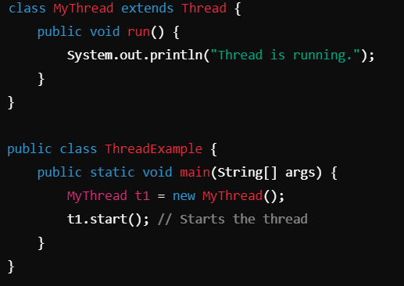
1. Extending the Thread Class: A thread can be created by extending the Thread class and overriding its run() method. When to Use: Use when the thread logic is tightly coupled with the class behavior. Code Example:

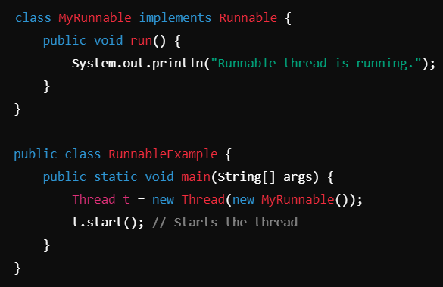
2. Implementing the Runnable Interface: A thread can also be created by implementing the Runnable interface. This approach decouples thread behavior from the class definition. When to Use: Use when the class needs to inherit from another class, as Java does not support multiple inheritance. Code Example:

Thread Methods
- start(): Starts a thread by invoking its run() method.
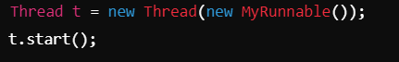
- run(): Contains the code that defines the task to be executed by the thread. If run() is called directly (without start()), it behaves like a normal method, not a thread.
- join(): Causes the current thread to wait until another thread completes its execution.
- sleep(ms): Puts the thread to sleep for the specified time in milliseconds.

- yield(): Hints the thread scheduler to allow other threads of equal priority to run.
- isAlive(): Checks if a thread is still running.
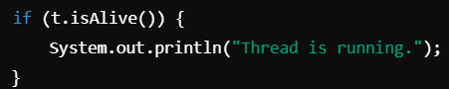

Thread Synchronization
Need for Synchronization:
- Synchronization is required to prevent race conditions, which occur when multiple threads access shared resources simultaneously, leading to unpredictable results.
- Synchronization ensures mutual exclusion, where only one thread accesses a critical section at a time.
Key Concepts:
1. Synchronized Block: Locks only the critical section of code, making it more efficient than synchronizing the entire method.
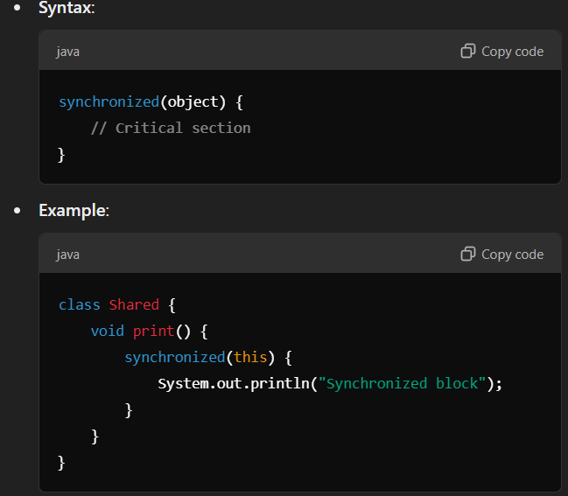
2. Synchronized Method: Locks the entire method so only one thread can execute it at a time.
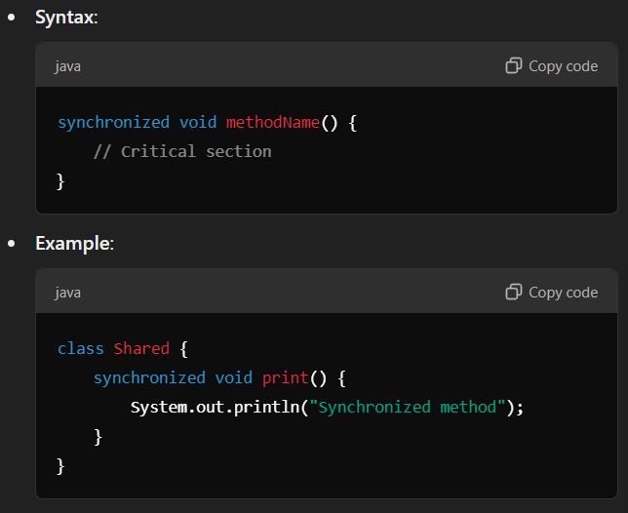
3. Static Synchronization: Synchronizes static methods. Since static methods belong to the class, the class-level lock is used.
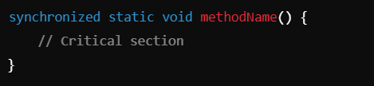
4. Locks: Java's java.util.concurrent.locks.Lock interface provides more advanced thread synchronization mechanisms than synchronized blocks or methods. Key Features:
  - Allows multiple lock conditions.
  - Explicit lock and unlock control.
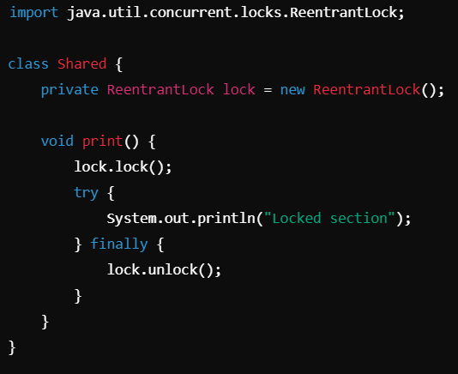

Inter-Thread Communication
Java provides the following methods to allow threads to communicate and coordinate their execution:
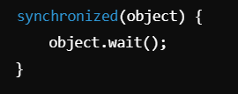
- wait(): Causes the current thread to release the lock and wait until another thread invokes notify() or notifyAll() on the same object. Must be called inside a synchronized block or method.
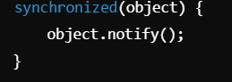
- notify(): Wakes up one waiting thread (if any) that is waiting on the same object. The thread must acquire the lock to proceed.
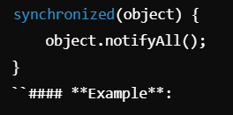
- notifyAll(): Wakes up all threads waiting on the same object. Only one thread proceeds after acquiring the lock.

Thread Priority
- Set and Get Priority
- Setting Priority: Use setPriority(int priority) to assign a priority to a thread. Java provides three constants:
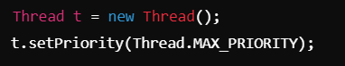
    - MIN_PRIORITY = 1
    - NORM_PRIORITY = 5 (default)
    - MAX_PRIORITY = 10
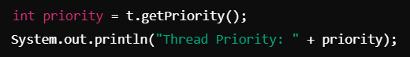
- Getting Priority: Use getPriority() to retrieve the priority of a thread.
How Priorities Work:
- Higher priority threads are more likely to be scheduled for execution, but priorities are platform-dependent.
- Priority does not guarantee execution order, as it depends on the thread scheduler.

Multithreading Utilities
Concurrency Utilities (java.util.concurrent): Java provides a rich set of utilities to simplify thread management and synchronization:
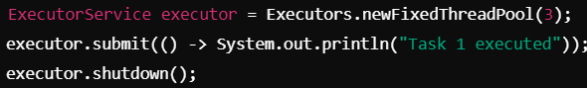
1. Executor Framework: A framework for managing thread pools efficiently.
- Benefits:
  - Eliminates manual thread creation.
  - Optimizes resource utilization.
- Key Interfaces:
  - Executor: Submits tasks for execution.
  - ExecutorService: Manages and controls thread lifecycle.
2. Callable and Future:
- Callable: Similar to Runnable, but can return a result and throw exceptions.
- Future: Represents the result of an asynchronous computation.
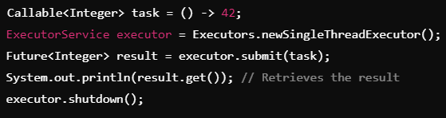
3. Advanced Synchronization Utilities:
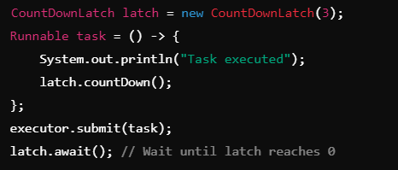
- CountDownLatch:Allows a thread to wait until a set of tasks complete. Example: Waiting for multiple services to initialize before proceeding.

- CyclicBarrier: Synchronizes multiple threads by forcing them to wait at a barrier until all threads arrive. Example: Useful for parallel tasks that must finish a phase together.

- Semaphore: Controls access to a shared resource using permits. Example: Limiting access to a critical section.
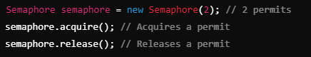
4. ForkJoin Framework: Designed for parallelism and dividing large tasks into smaller subtasks. ForkJoinPool manages threads efficiently for divide-and-conquer algorithms.
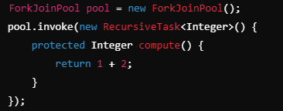

Deadlock and thread safe code
A deadlock occurs when two or more threads are waiting indefinitely for each other to release resources, preventing further execution. Example: Thread A locks Resource 1 and waits for Resource 2, while Thread B locks Resource 2 and waits for Resource 1. How to Avoid Deadlocks:
  - Acquire Locks in a Consistent Order: Always acquire locks in the same sequence in all threads.
  - Use Timeout: Use tryLock() with a timeout (from ReentrantLock) to prevent indefinite waiting.
  - Avoid Nested Locks: Minimize using locks inside other locks to reduce complexity.
  - Deadlock Detection Tools: Use monitoring tools or thread dumps to identify and resolve deadlocks.
Thread-Safe Code: ensures that shared data is accessed by threads in a way that prevents data corruption and unpredictable behavior. Ways to Ensure Thread Safety:
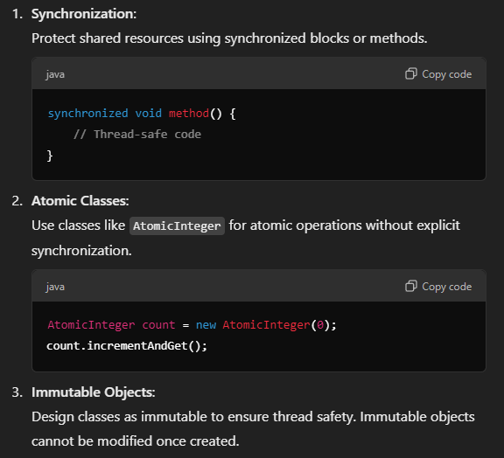
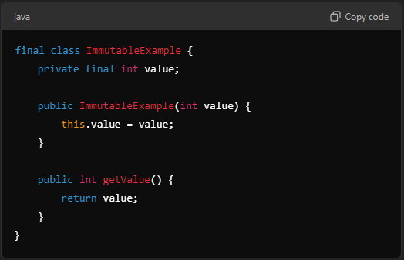

Daemon Threads
Daemon threads are background threads that run in the background to perform tasks like garbage collection or resource monitoring. Key Feature: Daemon threads automatically terminate when all user threads finish execution. Setting Daemon Threads: Use setDaemon(true) before starting the thread.
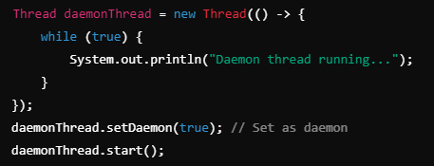
Use Cases:
- Garbage Collection
- Monitoring Services
- Background Logging

